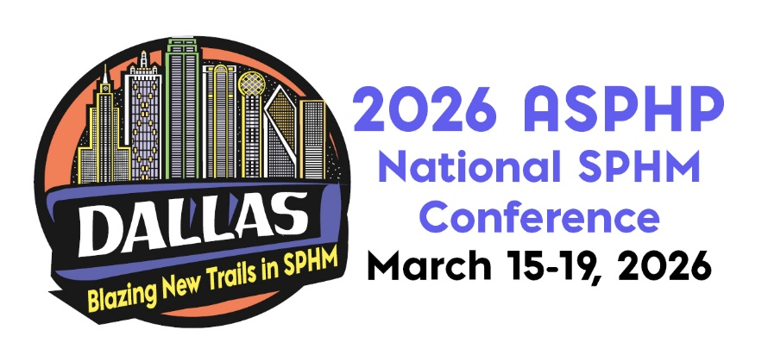

SPONSORSHIP OPPORTUNITIES/ EXHIBIT SPACE APPLICATION & INVOICE
PLEASE PRINT
Company Name
Contact Person * |  |  |  |  |  |  |  |  |  | Title
Address
City |  |  |  |  | State |  |  | Zip |  |  | Website
E-mail |  |  |  |  |  |  |  |  | Phone
Company Products/Services
How did you learn about this conference?
*Contact Person will receive all correspondence related to Exhibit Hall including special promotions, drayage, rental forms, invoices and booth personnel registration forms. Please forward to booth representatives.

SPONSORSHIP

Grand Opening Reception Sponsor $8,700 After Jul 31, 2025 $9,700
Keynote Speaker Sponsor $8,700 After Jul 31, 2025 $9,700
General Session Speaker Sponsor $7,500 After Jul 31, 2025 $8,500
Annual Membership Reception Sponsor $4,750 After Jul 31, 2025 $5,750
Lunch Sponsor $4,750 After Jul 31, 2025 $5,750 Day One Day Two
Break and Breakfast Sponsor $3,750 After Jul 31, 2025 $4,750
Select - Breakfast: Day One Day Two AND/OR
Break: Day One Morning Break Day One Morning Break
Day Two Morning Break Day Two Morning Break
Attendee Bag Sponsor $4,250 After Jul 31, 2025 $4,750
Lanyard Sponsor $3,300 After Jul 31, 2025 $3,800
Breakout Session Sponsor $1,750 After Jul 31, 2025 $2,250
Attendee Mailing List $250 per list pre-event post-event
Event Booklet Color Ad
Inside Front Cover, Inside Back Cover, Back Cover: Full page $1,450; Non- Exhibitor $1.750
Inside Page: Full Page $900; Non-Exhibitor $1,250
Inside Page: Half Page $600; Non-Exhibitor $750
Marketing Material in Attendee Bags: $500; Non-Exhibitor $1,000

EXHIBIT BOOTH Early Bird (before Jul 31, 2025) $4,700; Aug 1 – Dec 11, 2025 $5,700;
Dec 12, 2025 – Mar 6, 2026 $6,700

No Registration will be accepted after Mar 6, 2026.

No. of Booth Spaces Reserved |  | $
ASPHP Current Sponsor receives discount on exhibit booth.
Total Amount:

Payment Method
Credit Card (circle one) Visa MasterCard American Express Discover
Credit Card# |  | Expiration Date
Cardholder Name: |  | (3 or 4 digit security code)
Card billing address:

Check – Make payable to ASPHP. Mail to: ASPHP Headquarters, 10431 Perry Highway, Suite 210J, Wexford, PA 15090. Or e-mail your registration to Annie Wiest at awiest@asphp.org.

CANCELLATION POLICY: No refund will be made for any sponsorship cancellation. Should the exhibitor be unable to occupy and use the contracted exhibit space, the exhibitor must promptly notify the ASPHP National Office in writing. All sums paid for exhibit space by the exhibitor, less a handling charge of 40% of the net contract price, will be refunded if cancellation is made before Oct 31, 2025. All sums paid for the exhibit space by the exhibitor, less a handling charge of 60% of the net contract price, will be refunded if the cancellation is made before Jan 31, 2026. No refunds or cancellations will be made after Jan 31, 2026. After Jan 31, 2026, the exhibiting company will remain liable for the full cost of the original exhibit space.

Sponsorship opportunities and exhibit booths are first-come, first-served, due to the limited number of slots available. ASPHP reserves the sole and exclusive right to assign exhibit space.

