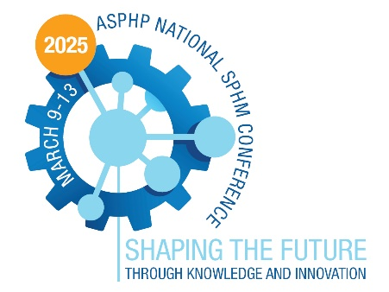
2025 ASPHP National SPHM Conference
March 10 – 13, 2025
Atlanta, GA

Poster Abstract Submission Guidelines

Submission Deadline: October 17, 2024
Author Notification by December 31, 2024

We extend an invitation to those interested in showcasing their research through a poster presentation at the 2025 ASPHP National SPHM Conference. Proposals should be submitted no later than October 17, 2024. These poster abstracts should be closely aligned with innovative and evidence-based research and projects in the field of safe patient handling and mobility (SPHM). We encourage topics that directly or indirectly support SPHM initiatives.

All submitted abstracts will undergo a peer-review process. Accepted abstracts will be featured in the conference materials. Lead authors will receive notification via email. To ensure participation in the conference, at least one author must register by February 1, 2025. Abstracts will be included in the event handouts only if registration fees have been paid by this deadline.

The poster boards provided will measure 8 feet in width and 4 feet in height. The Poster Abstract Committee retains the right to decline contributions that do not align with the conference's objectives or lack sufficient scientific or technological merit. Abstracts with promotional content or those advertising a specific company or product will not be accepted.

We welcome poster presenters to engage with colleagues in a relaxed and interactive setting, sharing their valuable research and projects with fellow professionals.

AWARDS – There are six categories of award. The Posters will be rated by the 2025 National Conference Committee. The Award Ceremony will be held at the National Conference.
- Best Overall Award: Outstanding poster award recognizing excellence in research, poster design and presentation.
- Innovation Award: Project utilizes new approach to using SPHM practices to expand adoption and integration into healthcare across all settings.
- Inclusive Voices Award: Diverse roles/disciplines, opinions, and approaches incorporated into poster research, design and presentation.
- Gallagher Award/Top Novice Award: Recognizes those who are early stages of their career or are just beginning to expand their skill set to include research, development of best practice and performance improvement.
- Excellence in Research Design Award: Poster displays best use of research methods (control group, statistical analysis, demonstrates a strong cause and effect relationship etc).
- Exemplary QI Project Award: Develops an investigative question and embarks on a quality improvement initiative to promote culture change within their organization/sphere of influence.

Submit your abstract on next page.

Poster Abstract Submission

LEAD AUTHOR (Please provide full name with credentials)
ADDRESS
CITY, STATE & ZIP
PHONE |  |  |  | EMAIL
CURRENT POSITION & EMPLOYER
LIST ALL CO-AUTHOR(S) NAME WITH CREDENTIALS AND CURRENT POSITION & EMPLOYER
POSTER INFORMATION
Title of Poster
Background/Abstract

Method
Finding (can be determined later if the project is still in process)
Conclusion
Evidence – Based References
(There is no limit to references. We encourage references less than 5 years old, unless used for historic purposes.)

Select the award category (except Best Overall) you would like to be considered:
☐ Innovation Award: Project utilizes new approach to using SPHM practices to expand adoption and integration into healthcare across all settings.
☐ Inclusive Voices Award: Diverse roles/disciplines, opinions, and approaches incorporated into poster research, design and presentation.
☐ Gallagher Award/Top Novice Award: Recognizes those who are early stages of their career or are just beginning to expand their skill set to include research, development of best practice and performance improvement.
☐ Excellence in Research Design Award: Poster displays best use of research methods (control group, statistical analysis, demonstrates a strong cause and effect relationship etc).
☐ Exemplary QI Project Award: Develops an investigative question and embarks on a quality improvement initiative to promote culture change within their organization/sphere of influence.

Presenter Agreement – please download and review the agreement before submitting your abstract. Click here to download the agreement.

By submitting this poster abstract, I (We) hereby consent to the use of my (our) presentation and other materials as described and agree with the provisions of this agreement if my (our) abstract is accepted.

Lead Author’s electronic signature
Lead Author’s full name
Date:

Execution of this agreement does not obligate ASPHP to publish your presentation or other materials.

Please send your submission to info@asphp.org.
Poster Abstract Submission Deadline: October 17, 2024.

