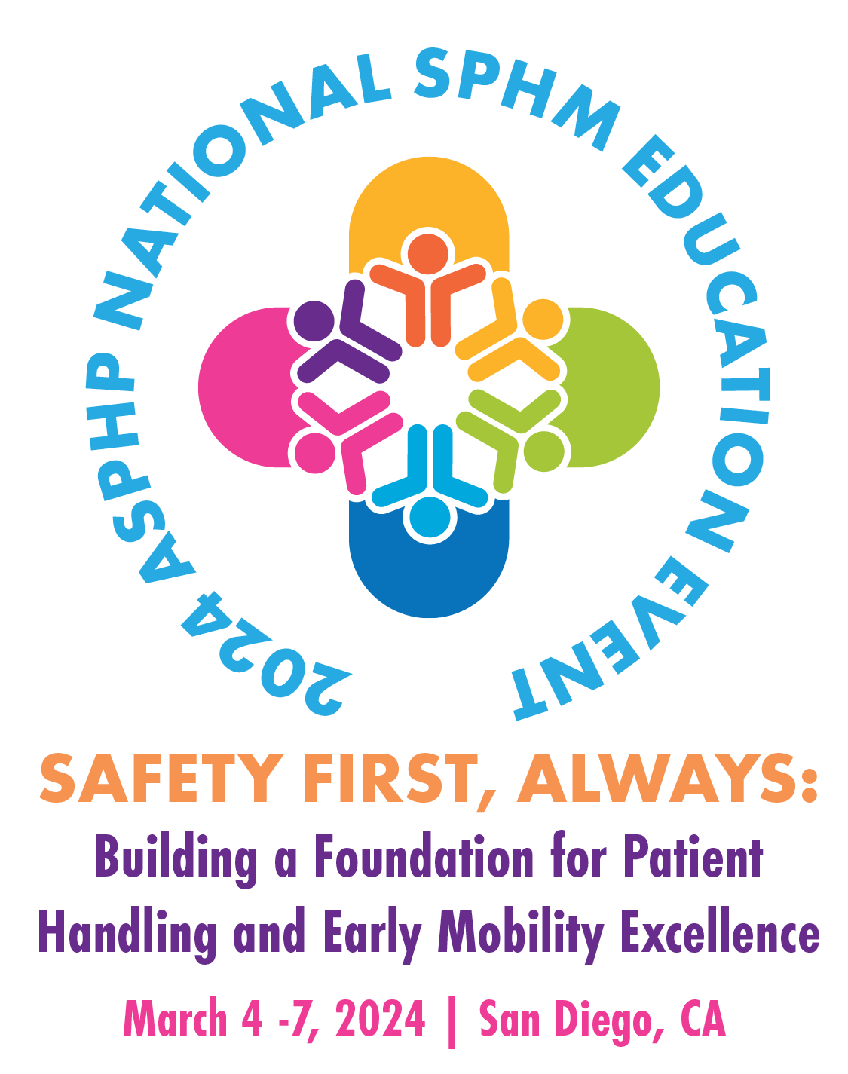

Poster Abstract Submission Guidelines

Submission Deadline: October 31, 2023
Author Notification by December 31, 2023

The Association of Safe Patient Handling Professionals (ASPHP) extends an invitation to those interested in showcasing their research through a poster presentation at the 2024 ASPHP National SPHM Education Event. Proposals should be submitted no later than October 31, 2023. These poster abstracts should be closely aligned with innovative and evidence-based research and projects in the field of safe patient handling and mobility (SPHM). We encourage topics that directly or indirectly support SPHM initiatives.

All submitted abstracts will undergo a peer-review process. Accepted abstracts will be featured in the conference materials. Lead authors will receive notification via email. To ensure participation in the event, at least one author must register by February 1, 2024. Abstracts will be included in the event handouts only if registration fees have been paid by this deadline.

The poster boards provided will measure 8 feet in width and 4 feet in height. The Poster Abstract Committee retains the right to decline contributions that do not align with the event's objectives or lack sufficient scientific or technological merit. Abstracts with promotional content or those advertising a specific company or product will not be accepted.

We welcome poster presenters to engage with colleagues in a relaxed and interactive setting, sharing their valuable research and projects with fellow professionals.

AWARDS – There are four categories of award. The Posters will be rated by the 2024 National Event Committee. The Award Ceremony will be held on at the National Event.

The following are the four categories.
- Best Overall: Outstanding poster award recognizes excellence in research, poster design and presentation.
- Innovation Award: New approach to using SPHM practices to expand adoption and integration into healthcare across all settings
- Inclusive Voices Award: Diverse roles, opinions, and approaches incorporated into poster research, design and presentation
- Gallagher Award: Recognizes those who are in the early stages of their career and are expanding their skill set to include research, sharing of best practices and performance improvement.

Submit your abstract on next page.

Poster Abstract Submission

LEAD AUTHOR (Please provide full name with credentials)
ADDRESS
CITY, STATE & ZIP
PHONE |  |  |  | EMAIL
CURRENT POSITION & EMPLOYER
LIST ALL CO-AUTHOR(S) NAME WITH CREDENTIALS AND CURRENT POSITION & EMPLOYER
POSTER INFORMATION
Title of Poster
Background/Abstract

Method
Finding (can be determined later if the project is still in process)
Conclusion
References used
(There is no limit to references used; however, we encourage references less than 5 years old, unless used for historic purposes.)

*PRESENTER AGREEMENT – please download and review the agreement before submitting your abstract. Click here to download the agreement.

By submitting this poster abstract, I (We) hereby consent to the use of my (our) presentation and other materials as described and agree with the provisions of this agreement if my (our) abstract is accepted.

*Lead Author’s electronic signature
*Lead Author’s full name
*Date:

Must complete all with “*” and sign to be accepted for submission.
Execution of this agreement does not obligate ASPHP to publish your presentation or other materials.

Please send your submission to info@asphp.org.
Poster Abstract Submission Deadline: October 31, 2023.

