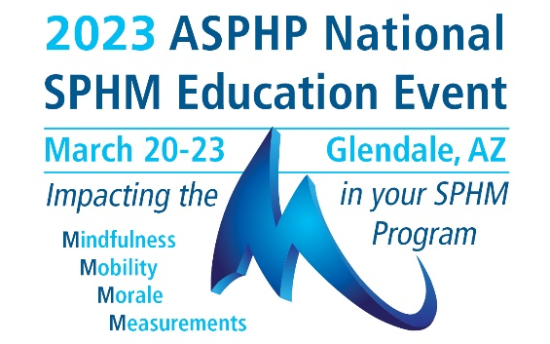

Poster Abstract Submission Guidelines

Submission Deadline: October 26, 2022
Author Notification by December 31, 2022

The Association of Safe Patient Handling Professionals (ASPHP) invites those interested in presenting a poster presentation at the 2023 ASPHP National SPHM Education Event to submit a proposal no later than October 26, 2022. Poster abstract submissions should align with sound and innovative safe patient handling and mobility (SPHM) research and project. Topics that support SPHM directly or indirectly are encouraged.
Submitted abstracts will be peer-reviewed. Accepted abstracts will be included in the conference materials.
All lead authors will be advised via e-mail. At least one author will be required to register for the Event. Abstracts will be included in the Event handouts only if at least one author has paid registration to attend the Event no later than February 1, 2023.
Poster boards are 8ˈw x 4ˈh. The Poster Abstract Committee reserves the right to refuse any contribution that is not appropriate to the Event or not of sufficient scientific or technological merit. Abstracts that are promotional in nature, or advertising a specific company or product, will not be accepted.
Poster presenters are invited to share their research/projects with colleagues in a casual and interactive environment.
AWARDS – There are four categories of award. The Posters will be rated by the 2023 National Event Committee. The Award Ceremony will be held on Thursday March 23 at the National Event. The following are the four categories.
- Best Overall: Outstanding poster award recognizes excellence in research, poster design and presentation.
- Innovation Award: New approach to using SPHM practices to expand adoption and integration into healthcare across all settings
- Inclusive Voices Award: Diverse roles, opinions, and approaches incorporated into poster research, design and presentation
- Gallagher Award: Recognizes those who are in the early stages of their career and are expanding their skill set to include research, sharing of best practices and performance improvement.

Submit your abstract on next page.

Poster Abstract Submission

LEAD AUTHOR (Please provide full name with credentials)
ADDRESS
CITY, STATE & ZIP
PHONE |  |  |  | EMAIL
CURRENT POSITION & EMPLOYER
LIST ALL CO-AUTHOR(S) NAME WITH CREDENTIALS AND CURRENT POSITION & EMPLOYER
POSTER INFORMATION
Title of Poster
Background/Abstract

Method
Finding (can be determined later if the project is still in process)
Conclusion
References used
(There is no limit to references used; however, we encourage references less than 5 years old, unless used for historic purposes.)

*PRESENTER AGREEMENT – please download and review the agreement before submitting your abstract. Click here to download the agreement.

By submitting this poster abstract, I (We) hereby consent to the use of my (our) presentation and other materials as described and agree with the provisions of this agreement if my (our) abstract is accepted.

*Lead Author’s electronic signature
*Lead Author’s full name
*Date:

Must complete all with “*” and sign to be accepted for submission.
Execution of this agreement does not obligate ASPHP to publish your presentation or other materials.

Please send your submission to info@asphp.org.
Poster Abstract Submission Deadline: October 26, 2022.

