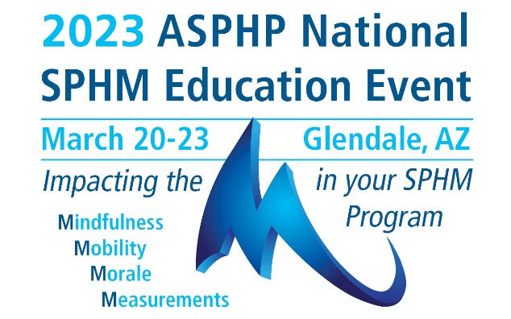

SPONSORSHIP OPPORTUNITIES/ EXHIBIT SPACE APPLICATION & INVOICE
PLEASE PRINT
Company Name
Contact Person * |  |  |  |  |  |  |  |  |  | Title
Address
City |  |  |  |  | State |  |  | Zip |  |  | Website
E-mail |  |  |  |  |  |  |  |  | Phone
Company Products/Services
How did you learn about this conference?
*Contact Person will receive all correspondence related to Exhibit Hall including special promotions, drayage, rental forms, invoices and booth personnel registration forms. Please forward to booth representatives.
SPONSORSHIP

Grand Opening Reception Sponsor $8,500 After Aug 31, 2022 $9,500
Keynote Speaker Sponsor $8,500 After Aug 31, 2022 $9,500
General Session Speaker Sponsor $6,000 After Aug 31, 2022 $7,000
Annual Membership Reception Sponsor $4,500 After Aug 31, 2022 $5,500
Break and Breakfast Sponsor $3,500 After Aug 31, 2022 $4,500
Select - Breakfast: Day One Day Two AND/OR
Break: Day One Day Two
Attendee Bag Sponsor $3,900 3,800 After Aug 31, 2022 $4,500
Lanyard Sponsor $3,200 After Aug 31, 2022 $3,700
Breakout Session Sponsor $1,500 After Aug 31, 2022 $2,000
Attendee Mailing List $200 per list
E-Blast Email Service $200 per email pre-event post-event
Event Booklet Color Ad
Inside Front Cover, Inside Back Cover, Back Cover: Full page $1,250
Inside Page: Full Page $800
Inside Page: Half Page $500

EXHIBIT BOOTH Early Bird (before Aug 31, 2022) $4,200; Sep 1 - Dec 31, 2022 $5,200;
Jan 1 – Feb 28, 2023 $6,000; Mar 1 – Mar 10, 2023 $6,800
No Onsite Registration will be accepted.
Special offer – Sign up before Jun 30, 2022 receive one free blast email to event attendees.
No. of Booth Spaces Reserved |  | $
ASPHP Current Sponsor receives 5% discount on exhibit booth.
Total Amount:

Payment Method
Credit Card (circle one) Visa MasterCard American Express Discover
Credit Card# |  | Expiration Date
Cardholder Name: |  | (3 or 4 digit security code)
Card billing address:

Check – Make payable to ASPHP. Mail to: ASPHP Headquarters, 125 Warrendale Bayne Road, Ste 375, Warrendale, PA 15086. Or e-mail your registration to Annie Wiest at awiest@asphp.org.

CANCELLATION POLICY: No refund will be made for any sponsorship cancellation. Should the exhibitor be unable to occupy and use the contracted exhibit space, the exhibitor must promptly notify the ASPHP National Office in writing. All sums paid by the exhibitor, less a handling charge of 40% of the net contract price, will be refunded if cancellation is made before August 31, 2022. All sums paid by the exhibitor, less a handling charge of 60% of the net contract price, will be refunded if the cancellation is made before Jan 31, 2023. No refunds or cancellations will be made after Jan 31, 2023. After Jan 31, 2023, the exhibiting company will remain liable for the full cost of the original exhibit space.

Sponsorship opportunities and exhibit booths are first-come, first-served basis due to a limited number of slots available. ASPHP reserves the sole and exclusive right to assign exhibit space.

We look forward to seeing you in Glendale, AZ!

