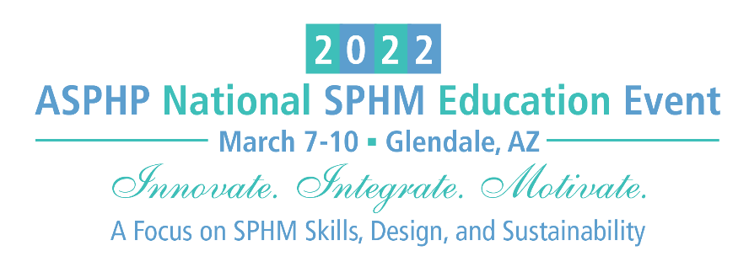

Poster Abstract Submission

LEAD AUTHOR (Please provide full name with credentials)
ADDRESS
CITY, STATE & ZIP
PHONE |  |  |  | EMAIL
CURRENT POSITION & EMPLOYER
LIST ALL CO-AUTHOR(S) NAME WITH CREDENTIALS AND CURRENT POSITION & EMPLOYER
POSTER INFORMATION
Title of Poster
Background

Method
Finding (can be determined later if the project is still in process)
Conclusion
References used
(There is no limit to references used; however, we encourage references less than 5 years old, unless used for historic purposes.)

AWARD - The Posters will be rated by the 2022 National Event Committee.
Select ONLY ONE of the following categories that your poster belongs to.
☐ | A. Enhancing SPHM program: Creative and novel approaches to integrate SPHM into organizational processes
☐ | B. Culture Change and SPHM: Focus on strategies to drive adoption of and engagement with SPHM practices
☐ | C. Innovative Use of Technology: Out-of-the-box or new approach to using SPHM technology
☐ | D. Research Based: Use of ‘best practice’ research-based approach, such as control groups, pre/post data, rigorous data analysis, etc.
☐ | E. Collaboration & Integration: Incorporate SPHM practices into broader quality improvement and safety initiatives, i.e. mobility program, fall prevention, HAPI prevention, LOS, etc.

*PRESENTER AGREEMENT – please download and review the agreement before submitting your abstract. Click here to download the agreement.

By submitting this poster abstract, I (We) hereby consent to the use of my (our) presentation and other materials as described and agree with the provisions of this agreement if my (our) abstract is accepted.

*Lead Author’s electronic signature
*Lead Author’s full name
*Date:

Must complete all with “*” and sign to be accepted for submission.
Execution of this agreement does not obligate ASPHP to publish your presentation or other materials.

Please send your submission to info@asphp.org.
Poster Abstract Submission Deadline: October 26, 2021.

