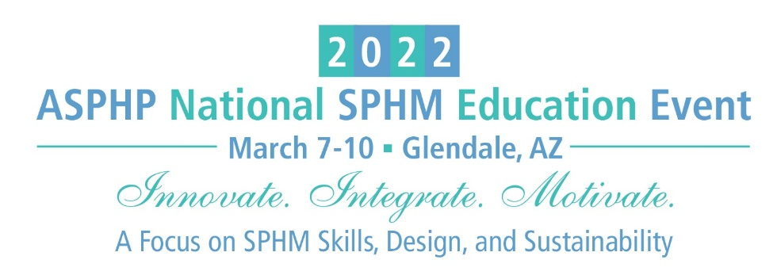

SPONSORSHIP OPPORTUNITIES/EXHIBIT SPACE APPLICATION
PLEASE PRINT
Company Name
Contact Person * |  |  |  |  |  |  |  |  |  |  | Title
Address
City |  |  |  |  | State |  |  |  | Zip |  |  | Website
E-mail |  |  |  |  |  |  |  |  |  | Phone
Company Products/Services
How did you learn about this conference?
*Contact Person will receive all correspondence related to Exhibit Hall including special promotions, drayage, rental forms, invoices and booth personnel registration forms. Please forward to booth representatives.
SPONSORSHIP

Grand Opening Reception Sponsor $8,000 After Nov 1, 2021 $9,000
Keynote Speaker Sponsor $8,000 After Nov 1, 2021 $9,000
General Session Speaker Sponsor $6,000 After Nov 1, 2021 $7,000
Annual Membership Reception Sponsor $4,000 After Nov 1, 2021 $5,000
Break and Breakfast Sponsor $3,000 After Nov 1, 2021 $3,500
Select - Breakfast: Day One Day Two AND/OR
Break: Day One Day Two
Attendee Bag Sponsor $3,800 After Nov 1, 2021 $4,300
Lanyard Sponsor $3,000 After Nov 1, 2021 $3,500
Breakout Session Sponsor $1,200 After Nov 1, 2021 $1,800
Attendee Mailing List $150 per list
E-Blast Email Service $150 per email pre-event post-event
Event Booklet Color Ad
Inside Front Cover, Inside Back Cover, Back Cover: Full page $1,150
Inside Page: Full Page $750
Inside Page: Half Page $450

EXHIBIT BOOTH Early Bird $4,000; Nov 1, 2021- Jan 31, 2022 $5,000
Feb 1 – Feb 21, 2022 $5,800; Feb 23, - Feb 28, 2022 $6,500
No Onsite Registration will be accepted.
No. of Booth Spaces Reserved |  | $
ASPHP Current Sponsor receive 5% discount on exhibit booth.
Total Amount:

Payment Method
Credit Card (circle one) Visa MasterCard American Express Discover
Credit Card# |  | Expiration Date
Cardholder Name: |  | (3 or 4 digit security code)
Card billing address:

Check – Make payable to ASPHP. Mail to: ASPHP Headquarters, 125 Warrendale Bayne Road, Ste 375, Warrendale, PA 15086. Or e-mail your registration to Annie Wiest at awiest@asphp.org.

CANCELLATION POLICY: No refund will be made for any sponsorship cancellation. Should the exhibitor be unable to occupy and use the contracted exhibit space, the exhibitor must promptly notify the ASPHP National Office in writing. All sums paid by the exhibitor, less a handling charge of 40% of the net contract price, will be refunded. No refunds or cancellations will be made after Nov 1, 2021. After Nov 1, 2021, the exhibiting company will remain liable for the full cost of the original exhibit space. Completion of the APPLICATION/INVOICE FOR SPONSORSHIP OPPORTUNITIES/EXHIBIT SPACE/ADVERTISING serves as the approval to charge the credit card provided on the form.

Sponsorship opportunities and exhibit booths are first-come, first-served basis due to a limited number of slots available. ASPHP reserves the sole and exclusive right to assign exhibit space.

We look forward to seeing you in Glendale, AZ!

