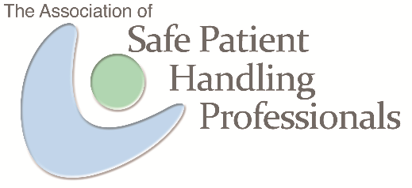

Association of Safe Patient Handling Professionals

2021 SPHM Advocacy Award

Nomination Form

Please use the Nomination Form, below, to submit an individual for consideration as the 2021 recipient of the Association of Safe Patient Handling Professionals Advocacy Award. A person who is making a valuable impact on SPHM deserves to be identified and acknowledged by their peers.

The purpose of this award is to recognize an individual who has demonstrated efforts and/or results to promote universal safe patient handling and mobility and/or who has made a meaningful impact through dedicated service and results, over either a short or long period of time. Nominees may work in any related profession; striving to achieve universal safety for all.

Nominations will be blind-reviewed by a panel of ASPHP members. This individual will be notified and recognized during the ASPHP Annual Membership Meeting.

QUALIFICATIONS: A minimum of two years involved with SPHM.

DEADLINE: Nominations must be received by January 6, 2021.

SUBMIT TO: Please e-mail the Nomination Form to the ASPHP: info@asphp.org.

QUESTIONS: Submit any questions to the ASPHP at the address shown above.

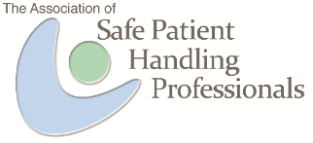

Association of Safe Patient Handling Professionals
SPHM Advocacy Award
Nomination Form:
1. Please complete the Contact Information sections for your nominee and yourself.

2. Please describe this person’s SPHM achievements based on the questions and criteria listed below. Provide evidence if possible. (No page limit, but keep a reasonable length)

- How specifically has the nominee advocated for SPHM?
- Give examples of the methods used and specific outcomes achieved.
- How has the nominee supported others in healthcare to support SPHM?
- Include anything else you would like us to know about this candidate as it relates to SPHM.

Selection Criteria:
- Scope of activities (one facility, one healthcare system, or national in scope)
- Interprofessional scope of activities (one profession, limited professions, or multidisciplinary with significant inclusion)
- Impact of advocacy activities on Caregiver Injury Reduction (anecdotal evidence, limited outcomes measured, or strong measurement of outcomes)
- Impact of advocacy activities on Quality of Care/Patient Safety (anecdotal evidence, limited outcomes measured, or strong measurement of outcomes)
- Impact of advocacy activities on Cost of Care (anecdotal evidence, limited outcomes measured, or strong measurement of outcomes).
- Short term impacts – for example, a new method(s). (limited to one facility, one healthcare system, or national in scope)
- Long term adoption - repeatable, sustainable change. (one facility, one healthcare system, or national in scope)

DEADLINE: Nominations must be received by January 6, 2021.

SUBMIT TO: Please e-mail the Nomination Form to the ASPHP: info@asphp.org.

Nominee Information:
Name:
Title:
Organization:
Address:
City, State Zip:
(Area Code) Phone number:
Email

Nomination Submitted By:
Name:
Title:
Organization:
Address:
City, State Zip
(Area Code) Phone number
Email

SPHM Advocacy Submission:
(No page limit, but keep a reasonable length)

