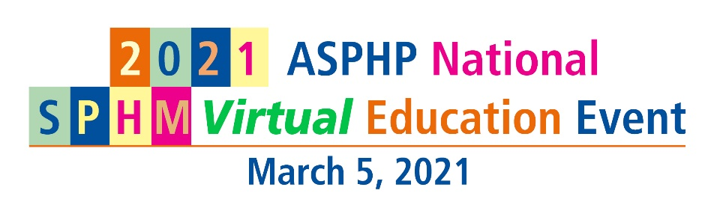

SPONSORSHIP OPPORTUNITIES/EXHIBIT SPACE APPLICATION
PLEASE PRINT
Company Name
Contact Person * |  |  |  |  |  |  |  |  |  | Title
Address
City |  |  |  |  | State |  |  | Zip |  |  | Website
E-mail |  |  |  |  |  |  |  |  | Phone
How did you learn about this conference?
*Contact Person will receive all correspondence related to national event.

SPONSORSHIP

Speaker Sponsor $3,500 After Nov 1, 2020 $4,500
Virtual Exhibit Booth $1,000 After Nov 1, 2020 $1,500
E-blast Email Service $500 per email
No. of E-blast Email |  | $
ASPHP Current Corporate Sponsor receives 5% discount on sponsorship and exhibit booth.
Total Amount:

Payment Method
Credit Card (circle one) Visa MasterCard American Express Discover
Credit Card# |  | Expiration Date
Cardholder Name: |  | (3 or 4 digit security code)
Card billing address:

Check – Make payable to ASPHP. Mail to: ASPHP Headquarters, 125 Warrendale Bayne Road, Ste 375, Warrendale, PA 15086. Or e-mail your registration to Annie Wiest at awiest@asphp.org.

CANCELLATION POLICY: No refund will be made for any sponsorship and Virtual Exhibit Booth cancellation. Completion of the APPLICATION/INVOICE FOR SPONSORSHIP OPPORTUNITIES/EXHIBIT SPACE/ADVERTISING serves as the approval to charge the credit card provided on the form.

Sponsorship opportunities and exhibit booths are first-come, first-served basis due to a limited number of slots available.

