Family brochure

Your hospital stay

Our staff at the VA will do everything we can to make your stay as comfortable and as safe as possible for you.



Before you came into the hospital you may have been able to get in and out of bed by yourself, move from the bed to the chair and get around with little or no help. But because of your illness, the pills you take or how tired you are, you may now need help with these things.

Healthcare has changed over the past ten years!

In the past, during your hospital stay, you may have been physically lifted, manually pulled or carried by several caregivers, making it uncomfortable, undignified, as well as unsafe for you! It also increased the possibility you might have been dropped or injured during your stay!

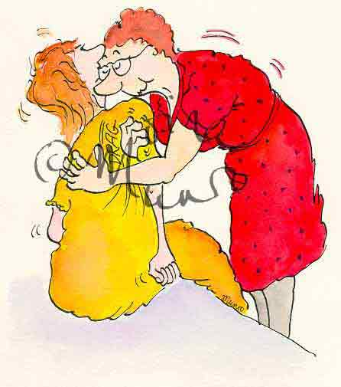

But that was then.

Today, our staff at the VA uses state of the art equipment to lift, move and help you with things like getting out of bed, moving to the bathroom or just getting comfortable in bed. The policy at this VA is to use our equipment to help you be as safe and as comfortable as possible whenever you need it. Our staff will answer your questions, give you time to get used to the equipment and let you learn how to feel safe with any piece of equipment that’s right for you!

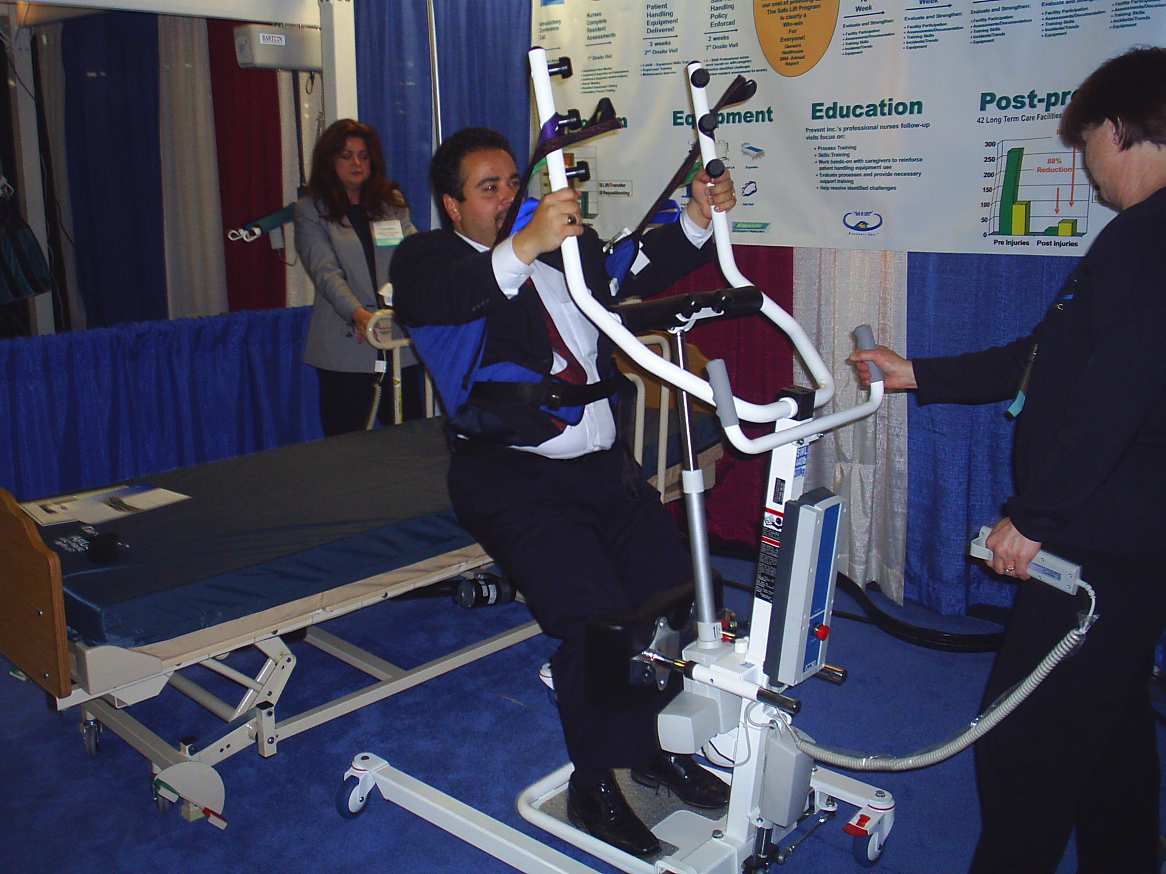

What to expect

You can expect to feel safe, secure and not embarrassed while using any of the equipment we have to help you move during your stay. Our staff is trained to select the right piece of equipment for you and they are expected to use that equipment to help you stay safe and feel at ease.

When you need help getting out of bed, instead of being pulled by your arms and then “tossed like a rag doll” into a chair, you can expect that our staff will use a sling and lift, or a slider board, or an air pal to gently and safely move you from the bed to the chair or a stretcher.
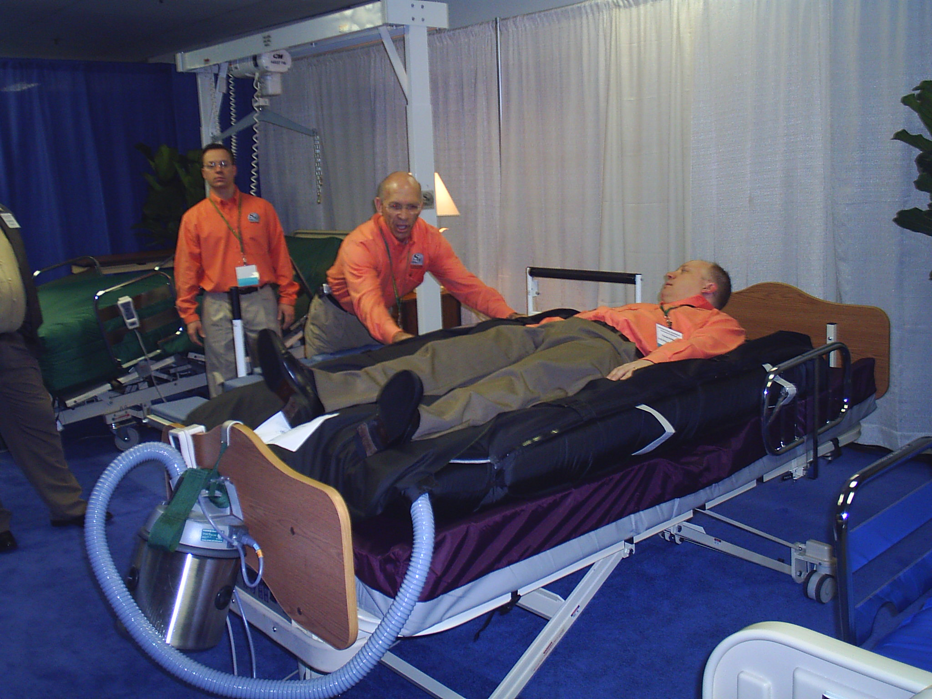

Instead of being hugged, tugged and pulled by several staff to get you to move from the chair to the walker, staff will use a piece of equipment called a “sit to stand” which will easily allow you to get up out of the chair, stand as best you can and use the walker without fear of falling down.

If you need help to move around in bed, instead of being dragged by one shoulder across the sheets and blankets, our staff will gently move you on an air mattress, a “slip and slide” sheet or a ceiling mounted lift to get you back to a spot where you can feel comfortable.

How it helps

In order for you to get the most out of your hospital stay, you need to get moving and keep moving! The state-of-the-art equipment our staff will use can help you with this mobility. Moving gets the circulation going, helps you breathe easier and makes you feel better. The equipment allows you to get the most out of moving around without fear or embarrassment. Our staff will do a complete assessment to make sure the equipment selected is right for you.

Your Rights

You have a right to be cared for with dignity. The equipment we use helps protect your dignity.
You have a right to receive safe care. The equipment we use is safe.
You have the right to ask your care givers to use the equipment to safely and comfortably assist with your movement.

